David Craig

The Microsoft Outlook Export Calendar to Word Add-in provides the ability to export and print custom calendars from Outlook that are not available by default.

Outlook Export Calendar to Word Add-in User Guide

Version 1.2.0.9

Table of Contents

Introduction 2

Installation 2

Usage 2

The Export dialog 3

The Names Dialog 3

Step by Step 4

Customizing Calendars 6

Fields 6

Preview 7

Supported Ranges 7

Support 7

# Introduction

The Microsoft Outlook Export Calendar to Word Add-in provides additional calendar printing options not available by default from Microsoft Outlook. For some users coming from Lotus Notes, for example, there are many calendar printing options not available. This add-in serves to fill some of those gaps, but also allow you to create your own calendars printing options as well. This add-in provides the following capabilities:

* Printing calendars not available in Outlook by default.
* The ability to create your own custom calendar
* The ability to combine calendars for multiple people at once:
  + Displaying only overlapping schedules on the same calendar
  + Displaying all meetings including overlapping meetings
* The ability to export in daily, weekly, by-weekly, tri-weekly or monthly formats.

When you select the date, names, and options you want for exporting and then export the calendar it will be opened in Microsoft Word as a fully editable document. From there you can do what you wish with the file:

* Print it
* Save as a PDF
* Save/Export as a web page.

This document will cover the installation, usage and customization of the Export Calendar to Word Add-in.

# Installation

The Microsoft Outlook Export Calendar to Word Add-in is supported on Outlook 2013 and Outlook 2016. To install the adding, please follow these steps:

1. Make sure Outlook is closed
2. Locate the “OutlookCalendarExport.vsto” and double-click on it.
3. This will install the add-in into Outlook. When completed, you will get a notification that it is installed.

**NOTE**: The add-in will automatically update. It is currently designed to look for an update from the location where you installed it every 7 days.

# Usage

To use the Microsoft Outlook Export Calendar to Word Add-in, you must switch to Calendar view. On the home tab a new “Export” group will appear on Home tab. You will press the “Export Calendar to Word” button:

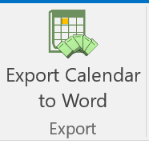

## The Export dialog

The Export Calendar to Word Options dialog is where you will set most of the options for printing. In this dialog you will be able to:

* Set the name (or names) of the people whose calendars you want to combine and print
* Choose whether you want to export all calendar items, only meeting items (versus meetings and appointments).

**NOTE**: An appointment it an individual item on a user’s calendar in which no other users are invited.

* Specify the template you wish to print. This will include template from the installation location (by default) as well as template stored in your My Documents \ **Outlook Custom Calendar Templates** folder.
* And additional options such as:
  + Including meeting locations with meeting items
  + Displaying only the times of a meeting but not the names of the meetings
  + Including the names of the users in the header.
  + Using *emphasis* to identify meetings that are recurring

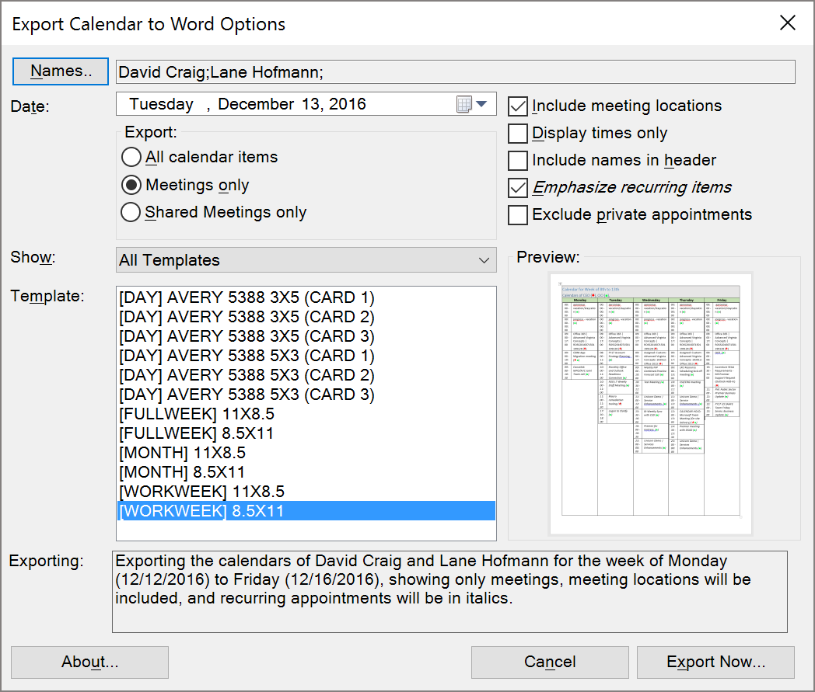

### The Names Dialog

When you click the “Names…” button on the “Export Calendar to Word Options” dialog you will see the Select Names dialog. In this dialog you will be able to:

* Select the names for users whose calendars you want to print
* The display options for those users:
  + A symbol which will be used on shared calendar printing to help identify which meeting or appointment belongs to which user.
  + A display name for the header if you wish to obfuscate the real name of the users.

**NOTE**: Only users whose calendars are added to your Outlook list of calendars will be available. If they have not shared their calendars with you, you will not be able to add them to Outlook, or use them in printing. If you try to add someone’s name to the Names dialog that is not shared, you will receive the following error:

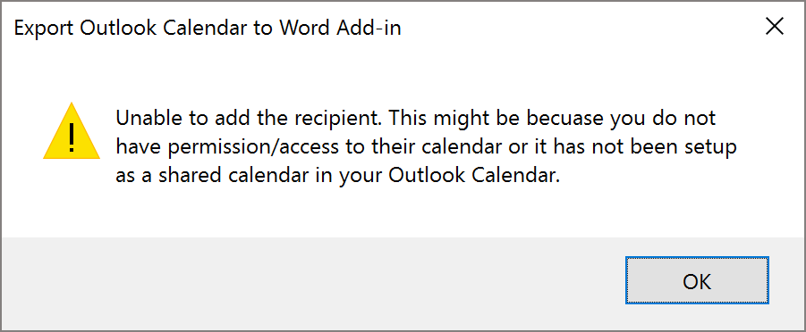

* And the ability to Save and Load blocks of names for reuse. For example, if you need to print the combined schedules of the CEO and CIO together but you also need to be able to print the VP of R&D with the COO you can save those two different combinations and load them again – as needed.
  + When you click Save you be asked to give the file a name. It will be stored as a *.OCEUL file (Outlook Export Calendar User List). It will be stored in the [%appdata%\Export Outlook Calendar to Word Add-in] folder by default.
  + When you click load, you will see all previously saved OCEUL files and you can select the one desired to have all its previously saved user setting loaded.

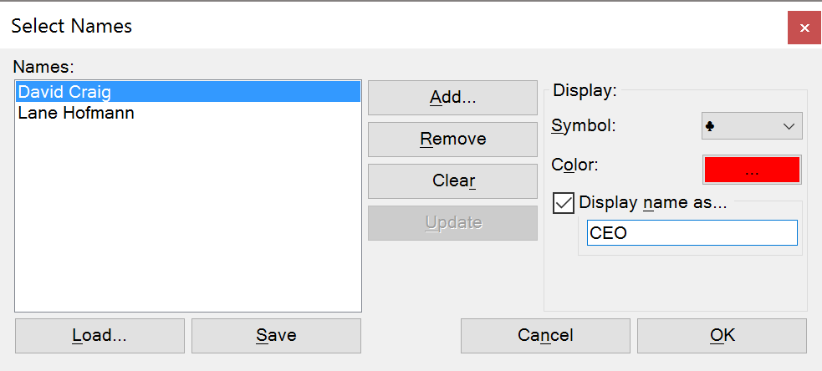

## Step by Step

The following is a step by step general usage scenario:

1. Open Outlook
2. Switch to your calendar
3. On the Home tab, click on the **Export Calendar to Word** button
4. Click the **Names…** button.
5. Click the **Add…** button.
6. From the address list, enter and select the name of the user you want to add.

**NOTE**: This person must have their calendar shared with you and you must have added them as a shared calendar in Outlook. If you have not, you will get an error.

1. Once you have added the name, you should select a Symbol and Color to differentiate the user from others on shared printed calendars. Additionally, you can specify an alternative display name – if desired.
2. Repeat steps 6 and 7 for each calendar you wish to combine when exporting.
3. If you also want, you can click **Save** to save this User List for later use. Click **Save** and then specify a name for the list and click Ok. This list will be saved and available in the future to load again, when you press the **Load** button.
4. Once you have all the names you wish to include, click Ok.
5. Next, specify the date you wish to have your calendar print. Of important note:
   1. If you select a daily calendar to export the date you select will be exported.
   2. If you select a weekly calendar and specify a date that is a Wednesday, the calendar will export starting on the previous Sunday automatically.
   3. If you select a monthly calendar and select any day in the month it will ALWAYS export starting at the first of the month. For example if you select the 20th of February the calendar will print the entire month of February (from the 1st to the 28th).
6. You will then select what types of items you wish to export: Meetings, Meeting and Appointments or just the shared meetings between all the folks selected in the Names list.

**NOTE**: If you have only one name in the Names list, the final option will not be available.

1. Next, you can select which type of template you with to print. By default there are a number of templates to choose from:
   1. Daily templates, including 3x5 options.
   2. Weekly templates including weekday and full week options
   3. Bi-weekly options
   4. Monthly options
2. Once you have selected the names, date, types and template, you can further refine your options using the check-boxes to the upper-right of the dialog:
   1. **Include Meeting Locations** – this option will add the meeting location specified in the meeting item in the exported template.
   2. **Display Meeting Times Only** – this option will provide generic names of the meetings (obfuscating the nature and names of meetings).
   3. **Include names in the header** – By default, all of the templates provided place the names selected for export in the header. This option will remove that header field from the exported document.
   4. **Emphasize recurring meetings** – this option will italicize all recurring meetings found.
   5. **Exclude private appointments** – this option will remove appointments and meetings marked as private from the exported document.
3. Once you have selected all your options click **Export Now…**
4. While exporting, the adding will perform this work:
   1. It will collect all the calendar entries from all the users you included for the dates specified (determined by the date selected and the template chosen).
   2. It will locate any meetings that are the same between users and combine them.
   3. It will then load the template in Word and start to fill in the values.
   4. Once complete Word will remain opened with an exported calendar that will match the options you specified.

# Customizing Calendars

The Export to calendar wizard provides for the ability to customize your own templates. Any templates you place in the My Documents \ **Outlook Custom Calendar Templates** folder will be included in the Export Calendar to Word dialog with a asterisk (*) at the end of the name.

You might want to create a custom template when:

* The options available do not meet your needs
* You wish to include custom graphics or colors on the calendar
* You wish to create a calendar type that is supported but not provided (3-week version).

To customize it might be best to open an existing calendar from the installation location (it might have an extension .deploy), rename this by removing the .deploy extension.

**NOTE**: You might need to enable extension in Windows to do this.

## Fields

When you view an existing template, you will see the following fields that you can use:

|  |  |
| --- | --- |
| Field Name | Description |
| <<header>> | This is where the name, date and range of the calendar are going to be placed. |
| <<name>> | This is where the names and symbols (with colors) are placed to denote which users calendars were combined. |
| <<day#>> | These are day markers on some weekly, and monthly calendars to identify the day of the week. Some of these will be deleted and some of these will be used. <<day1>> for example does not denote the first day of the month, only the first ordinal spot in the calendar. For example, if the first day of the month is a Wednesday, <<day4>> might be user for the 1st and <<day1>> to <<day3>> will be deleted. |
| <<time#>> | The time of a meeting. These ordinals MUST be used in conjunction with the same number for <<day#>> and <<title#>>. This is the time of the meeting. When the add-in needs to add multiple entries for a date, it will use <<time#>> and <<title#>> as a template for each entry for that day. |
| <<title#>> | This will hold the title of the meeting. It must be used in conjunction and the same ordinal number as <<day#>> and <<time#>> |

## Preview

To create a preview for your template, simply use it one time (sane preview) in the add-in, select the exported region with a tool like the Windows Snipping Tool and save the result as a PNG with the SAME NAME as the template in the same folder. The add-in will locate this preview when the user selects your template.

## Supported Ranges

The add-in supports these date ranges for customization:

* Day
* Days (less than a week)
* Weeks (full or work)
* Bi Weekly (full or work)
* Tri week (full or work)
* Monthly

# Support

THIS SOFTWARE IS PROVIDED 'AS IS' AND ANY EXPRESSED OR IMPLIED WARRANTIES ARE DISCLAIMED. PLEASE CONTACT YOUR HELP DESK FOR ASSISTANCE.